CHAPTER 6

In the previous chapters, we discussed the different communication methods that are used for continuous–time signals. Starting with chapter, we will talk about digital communication techniques. Before we can study the digital communication techniques, we need to study how to convert analog signals to digital signals. The first step in this process is called SAMPLING. In sampling, we convert continuous–time analog signals (signals that are defined at all time instants and have amplitudes that may take any real value) to discrete–time analog signals (signals that are defined at specific instants of time but still have amplitudes that may take any real value).

Sampling

A continuous–time analog or digital signal is defined at all time instants. On the other hand, a discrete–time analog or digital signal is defined only at some time instants. A simple method to sample a continuous–time signal at a specific time instant is to multiply this signal by a delta function that occurs at the time instant of interest. For example, let the signal g(t) be a continuous–time signal with bandwidth 2πB rad/s (B Hz). The signal g_{s}(t) given by

is zero everywhere and a delta function at time t₀ with an area (we will also call it magnitude) that is equal to the value of g(t) evaluated at t₀, that is a magnitude of value g(t₀). This represents getting only one sample of g(t). If we want to sample g(t) periodically every T_{s} then we can repeat this process periodically. That is, multiply the signal g(t) by a train of delta functions that occur every T_{s} seconds. A train of delta function δ_{Ts}(t) that occur every T_{s} is given by

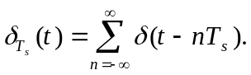

Therefore, the sampled signal‾g(t) is given by

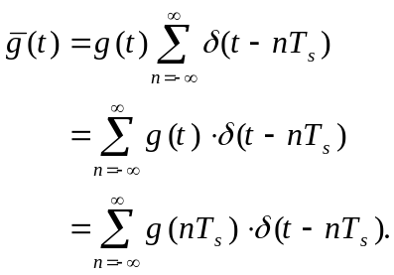

So, the sampled signal is a sum of delta functions that have magnitudes equal to the value of g(t) at the time instants that the delta functions occur. The following figure shows a signal g(t).

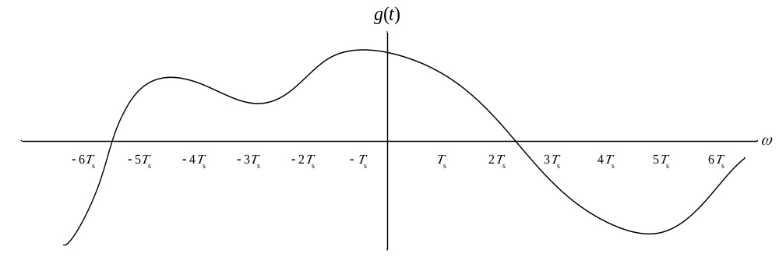

and the following figure show the sampled signal ‾g(t) where the amplitude of the deltas follows the original signal g(t).

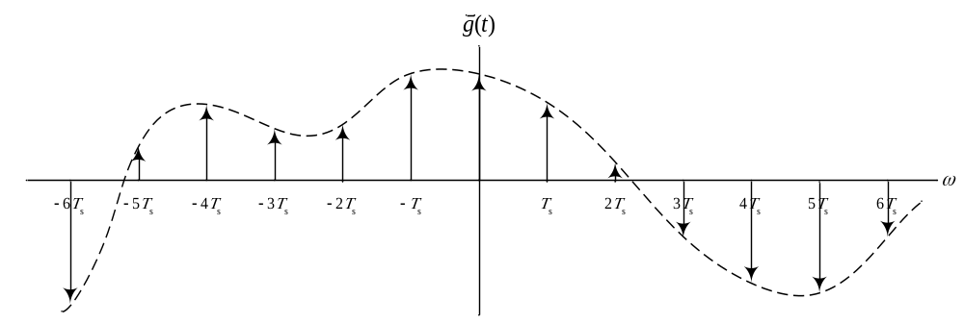

Sampling (Continuation)

Assume that the spectrum of g(t) is given by G(ω) shown below.

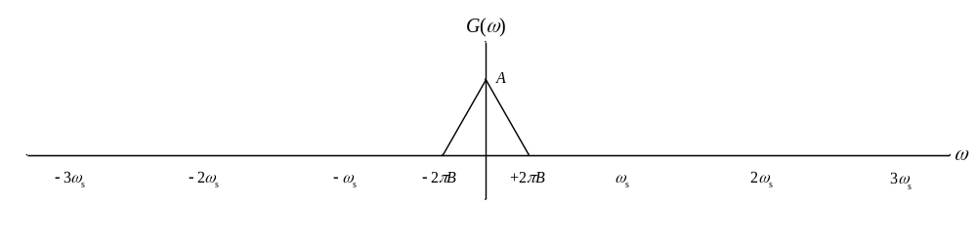
We can get the spectrum of ‾g(t) by find the spectrum of the train of delta functions and convolving it with G(ω), or by decomposing the train function into sine and cosine functions and then taking the Fourier transform of each element independently. Since the train of delta functions δ_{Ts}(t) is periodic, we can decompose it using the Fourier series as

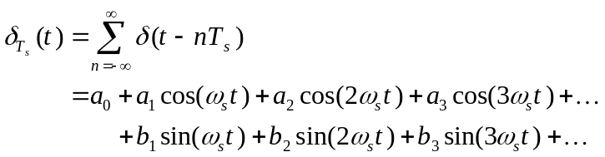

where T_{s} and ω_{s} are related by

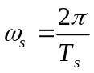.

The value of a₀ is

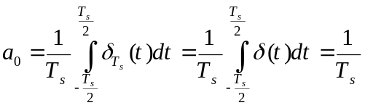,

and the value of the a_{n} for any n ≥ 1 is

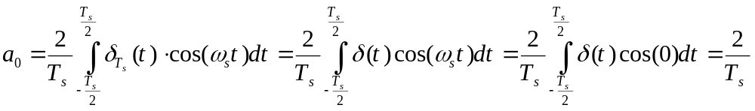.

Also, the value of b_{n} for any n ≥ 1 is

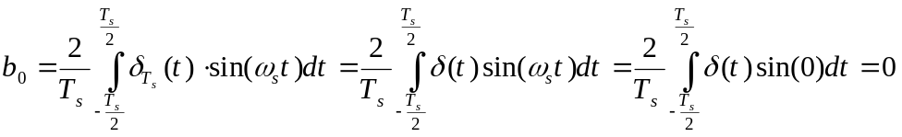.

Therefore,

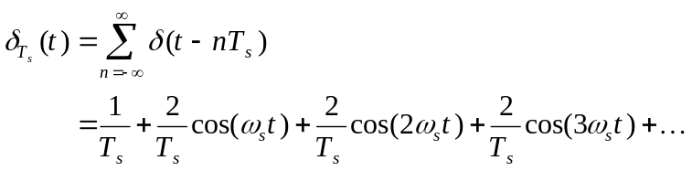

and

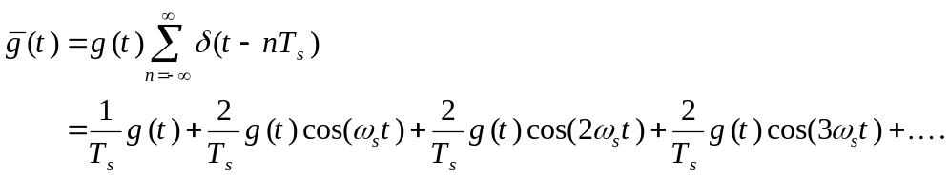

So, by taking the Fourier transform of each term of the above independently, we see that the spectrum ‾G(ω) is given by

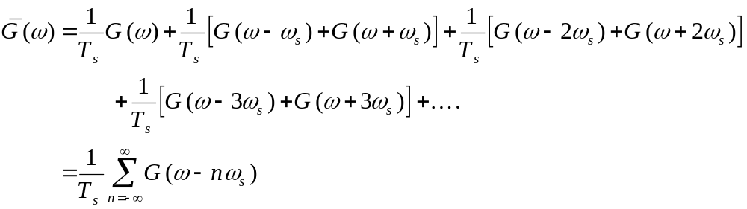

or simply scaled copies of the spectrum of the original continuous–time signal at multiples of the sampling frequency ω_{s}. Therefore, the spectrum of the sampled signal would be

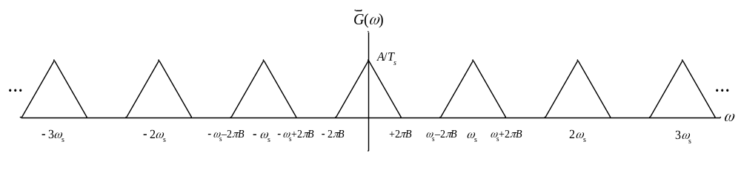

To extract the original signal from the sampled signal, it is clear that using a LPF with bandwidth equal to the bandwidth of the original signal g(t) (which is 2πB rad/s in this case) will do the job. However, this is true only if the signal was sampled at a sampling rate that is greater than twice the bandwidth of the signal.

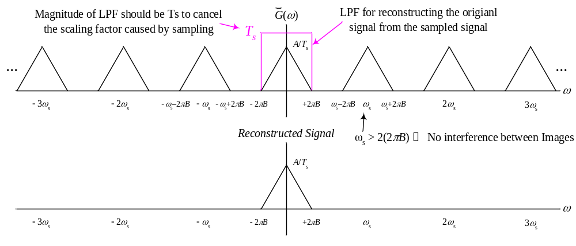

If the signal was sampled at a sampling rate lower that 2 times the bandwidth of the signal (called the NYQUIST SAMPLING RATE), the different spectral components of the sampled signal (called IMAGES) will interfere with each other and reconstructing the original signal will be impossible. This is illustrated in the following figure. The dark parts in the figure represent parts of the sampled signal and reconstructed signal that have been damaged.

